Project Zealot

Haojun Li, 24261499



1. The Link to the Repo is <https://github.com/cs160-sp16/prog-02-represent-LithiumH>
2. The Link to the Video is <https://youtu.be/L4Yd0gQ9iSo>

# Description:

This project explores the idea of delivering House can Congress candidate information to the user in a fast and convenient manner. The application is on both a wearable watch and the phone. With only a few clicks, the user is able to either see candidates’ information of their current location, or any other location by zip code, or even a random location just for fun.

# Changes to Proj02-A:

1. Unified typeface:

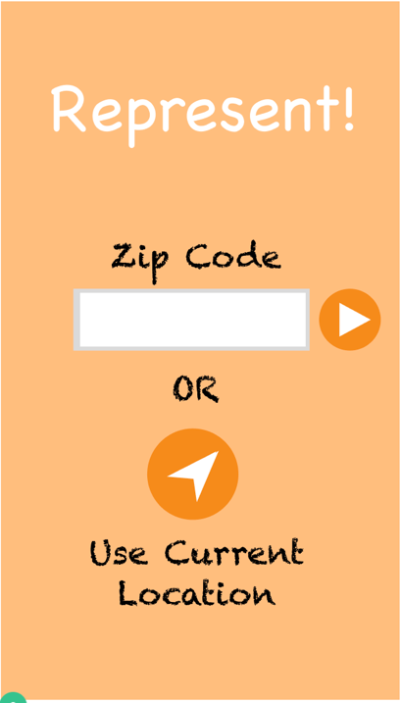 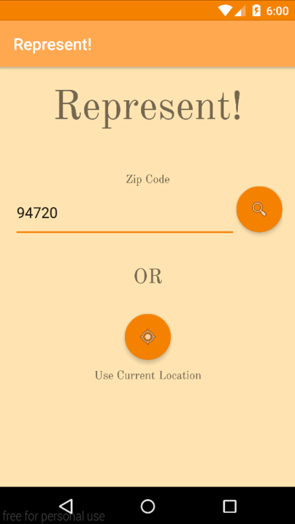

Figure 1: Proj02-A starting view Figure 2: Proj02-C starting view

Not only did I unify the typeface, I also changed the typeface to a more serious one instead of a chalky one. I also changed the icons to be more intuitive.

1. **Changed Loading Screen**

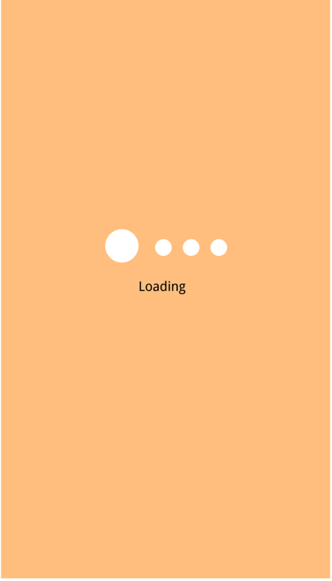 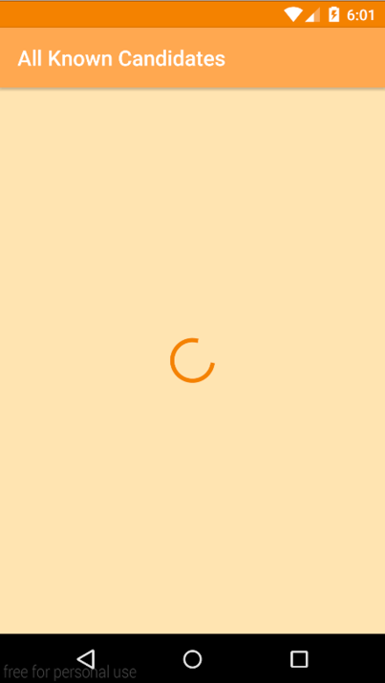

Figure 3: Loading Screen A Figure 4: Loading Screen C

I changed the loading screen to be more consistent with Google’s other application’s design to give the user more familiarity.

1. **Items Edge no long Mitered**

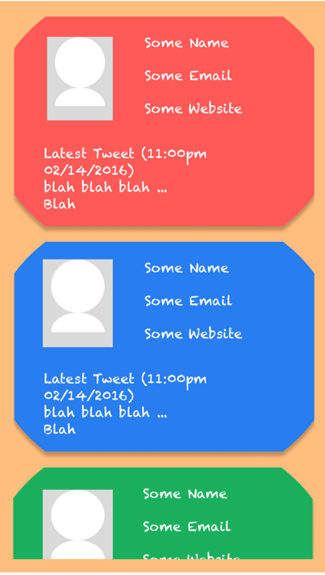 

Figure 5: Candidate View A Figure 6: Candidate View B

I took the suggestion from the TA to change the edges back to a square.

1. **Changed watch views**

 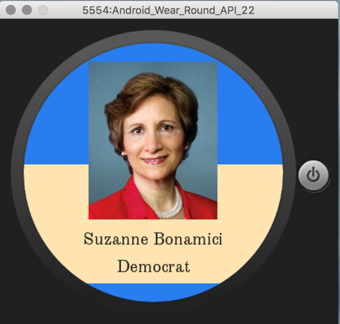

Figure 7: Watch View A Figure 8: Watch View B

The reason for this change is that the continuous strip on the bottom feels more natural and consistent with other applications compared to a white square. Unified typeface to mobile as well.

# Screen Shots:

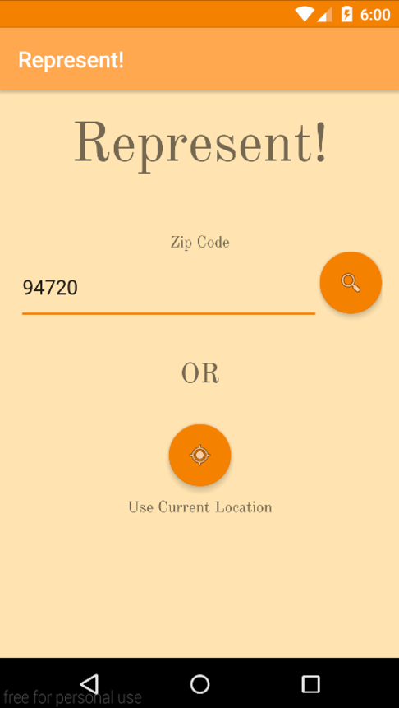

Figure 9: Main View Mobile

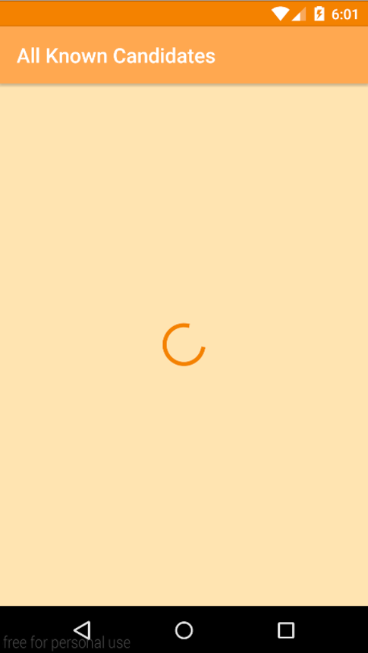

Figure 10: Loading Screen



Figure 11: All Candidate View



Figure 12: Detailed View 1

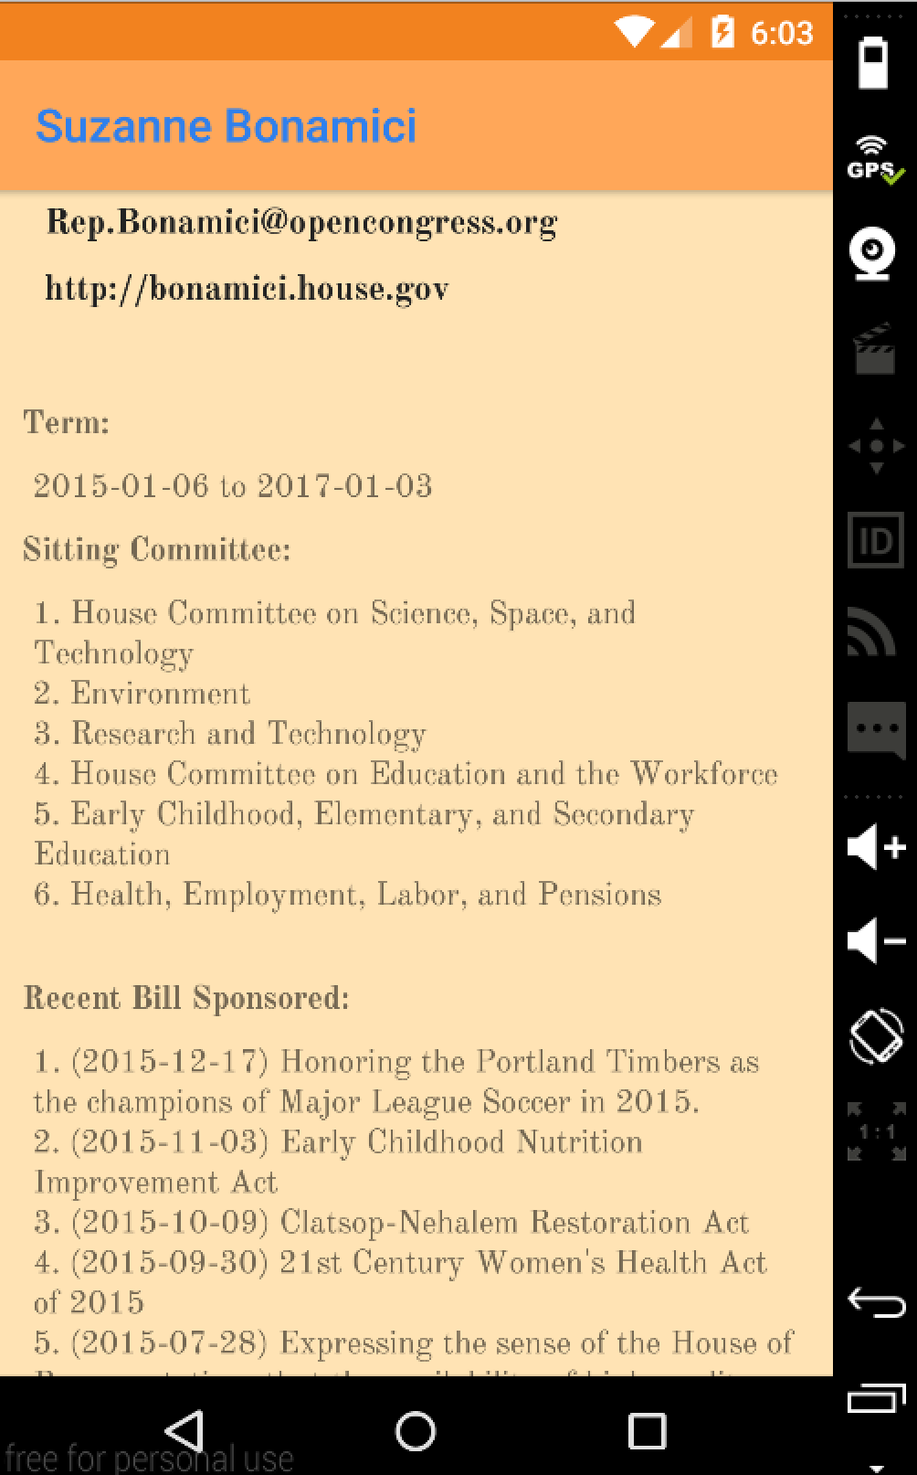

Figure 13: Detailed View 2

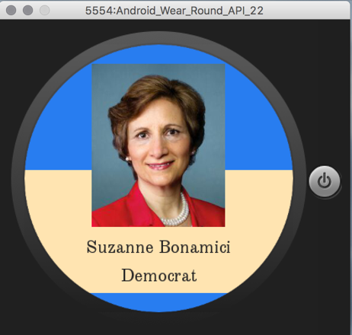

Figure 14: Watch View

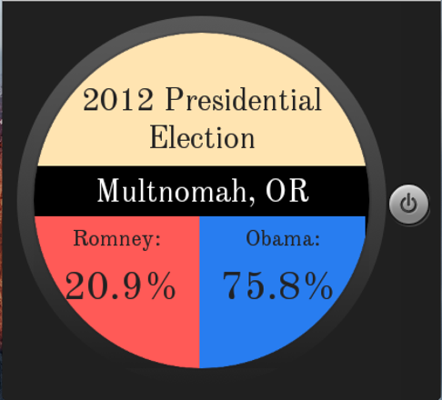

Figure 15: Election View